**FULL SUBTRACTOR USING ONLY NAND GATE**

**EXP NO: 32**

**AIM:** To design and implement full subtractor using only NAND gate with Logisim simulator.

**ALGORITHM:**

1. Connect the inputs to the NAND gate.
2. Start the connections according to the logic diagram, finish it reaching the designated inputs.
3. Connect the outputs to the gates.
4. Check and verify the truth table.

**DIAGRAM:**

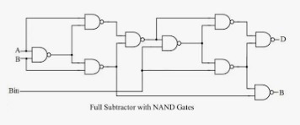

**TRUTH TABLE:**

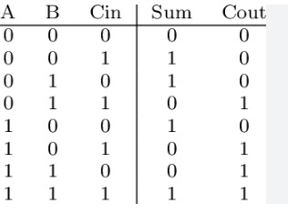

**OUTPUT:**

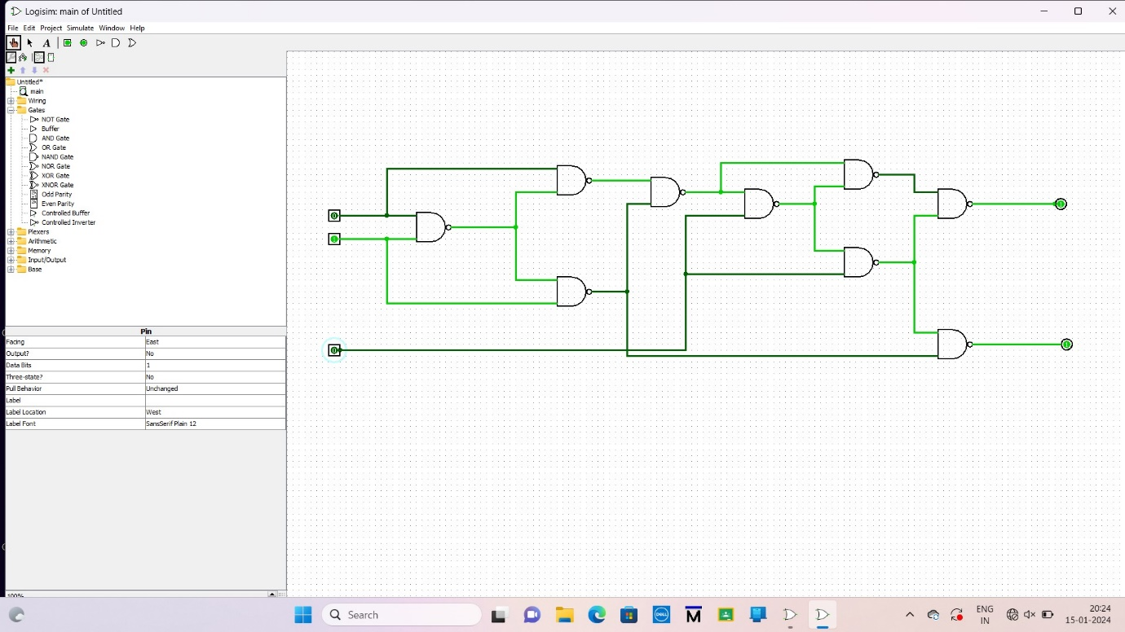

**RESULT:** Thus theimplementation of full subtractor using only NAND gate with Logisim simulator was executed successfully.